Khyber Pakhtunkhwa Information Technology Board (KPITB)
Plot # 134-136, Industrial Estate, Hayat Abad Peshawar, KP

To: [Name and Address of Bidder]

Procurement Reference: PK-KPITB-184209-GO-RFQ Date: 21/04/2021
Dear Sir,
PROJECT: DIGITAL JOBS IN KHYBER PAKHTUNKHWA
REQUEST FOR QUOTATIONS FOR [Procurement of Different Types of Printing Material for the Project Period]

The Khyber Pakhtunkhwa Information Technology Board (KPITB) invites your quotation for the items described above.
The KPITB has received a grant from the MDTF administered by the World Bank, intends to apply the proceeds of this grant to eligible payments under the contract for which this Request for Quotations is issued. This procurement process will be conducted in accordance with the shopping procurement method contained in the World Bank Guidelines July 2016 and the procedures described herein.
- Preparation of Quotations: You are requested to quote for these items by completing, signing and returning:
- the List of Goods and Price Schedule;
- the documents confirming your eligibility, as listed below;
The standard forms in this RFQ may be retyped for completion but the Bidder is responsible for their accurate reproduction.
- Validity of Quotations: The quotation validity required is 90 days.
- Sealing and marking of Quotations: Quotations should be placed in a single sealed envelope, clearly marked with the Reference above, the name of the Bidder and the Implementing Agency.
- Submission of Quotations: Quotations should be submitted to the address below by mail, by the date and time of the deadline below.
Date of deadline: 28/04/2021. Time of deadline: 11:00AM. Time of Opening: 11:30AM.
Address: Plot # 134-136, Industrial Estate, Hayat Abad, Peshawar
Facsimile: 091-9217486. Email: Irfan.wahab@digitaljobskp.com & irfanwk81@gmail.com
- Eligibility Criteria: You are required to meet the following criteria to be eligible:
- Supplier shall be registered with FBR and shall be an active tax payer
- The supplier shall be an authorized partner/dealer/distributer/reseller
- Have completed atleast 3 projects of similar nature and amount
- Suppliers who previously failed to delivered goods/services within the given time or incomplete are not eligible to apply;
- Have the legal capacity to enter into a contract;
- Not be insolvent, in receivership, bankrupt or being wound up or subject to legal proceedings for any of these circumstances;
- Not have had your business activities suspended or debarred from public procurement by the Office of Government Public Contracts Policy;
- Be eligible, as defined below;
- Documents Evidencing Eligibility: You are requested to submit copies of the following documents as evidence of your eligibility.
- Valid trading licence or equivalent;
- Valid certificate of registration or equivalent;
- Valid registration certificate with FBR and proof of active tax payer
- Affidavit of non-blacklisting/non-bankrupt
- Proof of 03 similar projects completed (POs/contracts)
- Origin of Goods: All Goods and related services shall have as their country of origin an eligible country.
- Technical Criteria: The Specification details the minimum specification of the Goods required. The Goods offered must meet this specification.
- Currency: Quotations must be priced in Pakistani rupees.
- Best Evaluated Bid: The best evaluated bid shall be the lowest priced quotation, which is eligible and technically compliant.
- Delivery: Prices should be quoted CIP (named place of destination) for imported goods and ex factory for domestically supplied goods [or DDU (named point)] according to Incoterms 2000.
- Duties and Taxes: The quoted price shall be inclusive of all Government applicable duties and taxes.
- Delivery Schedule: Delivery required should be 03 weeks from date of Purchase Order.
- Warranty: N/A.
- Terms of Payment:
Payment shall be made within 30 days against submission of your Invoice and supporting documents following delivery of the Goods.
- Eligible Countries: Pakistan only
- Samples: The bidders must submit samples of all the items at the time of RFQ Submission.
Any resulting contract awarded shall be by placement of a Purchase Order.
Any queries should be addressed to the Project Management Team at the address given above. Please prepare and submit your quotation or inform the undersigned if you will not be submitting a quotation.

Yours sincerely,
______________________
Irfan Wahab,
Procurement Manager
Statement of Requirements
List of Goods and Price Schedule
Procurement Reference: PK-KPITB-184209-GO-RFQ
We offer to supply the items listed below in accordance with the terms and conditions stated in your Request for Quotations referenced above.
We confirm that we are eligible to participate in public procurement and meet the eligibility criteria specified in the Request for Quotations.
The validity period of our quotation is: _______________ days/weeks/months.
We confirm that the prices quoted in the List of Goods and Price Schedule are fixed and firm for the duration of the validity period and will not be subject to revision or variation.
The delivery period offered is: _________days/weeks/months from date of Purchase Order.
The warranty period offered is _______________months.

Currency of Quotation: ____________________
Item No | Item | Description of Goods | Quantity | Unit of Measure | Country of Origin | Unit Price  [Incl. Taxes] | Total Price  [Incl. Taxes]
1 | Bag (L X H X W: 11.25 X 11.5 X 4 inches). | Customized goodie bag with logos | 250 | Nos.
1 | Bag (L X H X W: 11.25 X 11.5 X 4 inches). | Fabric with extra pockets
2 | Diary | 100 Pages Diaries, Hardcover with Logos on each Page. | 300 | Nos.
3 | Mug (High quality) | With Logos, multi colours | 400 | Nos.
4 | Pen | Ballpoints with logos | 500 | Nos.
5 | Tissue Box | Tissue boxes with logos | 200 | Nos.
6 | File covers (Legal) | With pockets and Logos | 1,000 | Nos.
7 | Shields (9 x 4.5 inches) | As designed | 90 | Nos.
8 | Visiting Card | Project Director, Dy. Director and staff of DJ in KP (Total 07 staff, 1000 for each staff) | 9,000 | Nos.
9 | Employee IDs | For All Staff | 20 | Nos.
10 | Brochure (4 Colour) | For the promotion of WorkAround | 1,000 | Nos.
 |  |  |  |  | Other additional costs
 |  |  |  |  | Subtotal
 |  |  |  |  | Total

Prices quoted are: Inclusive of Taxes, Transportation and Installation charges
Quotation authorised by:

Signature: | ___________________________ | Name: | ____________________________
Position: | ___________________________ | Date: | ____________________________
Authorised for and on behalf of: |  |  | (dd/mm/yy)
Company: | _________________________________________________________________

Technical Specification
Procurement Reference: PK-KPITB-184209-GO-RFQ
S. No | Item
1 | Bag (L X H X W: 11.25 X 11.5 X 4 inches). | 
2 | Diary | 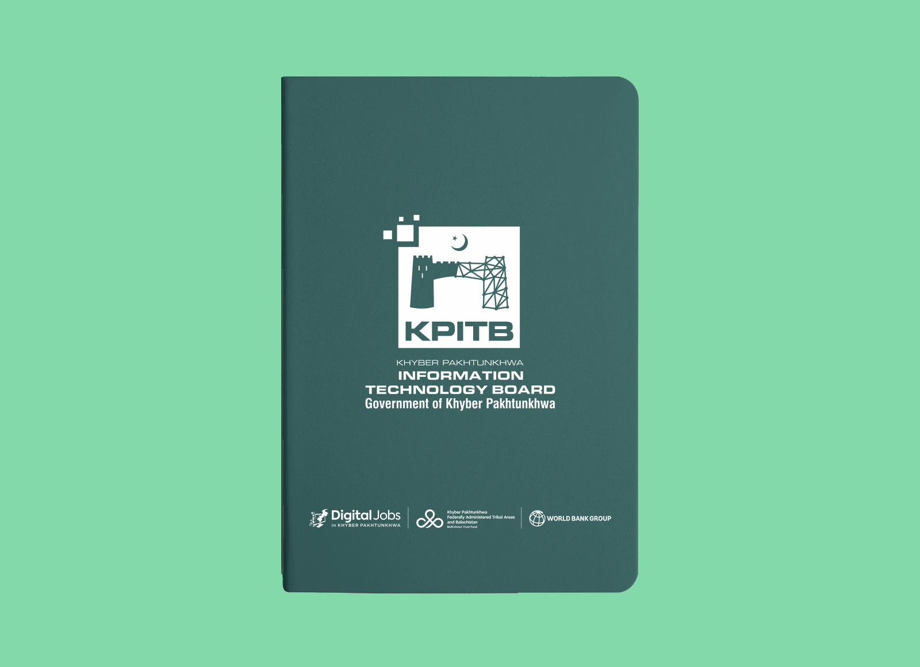
3 | Mug (High quality) | 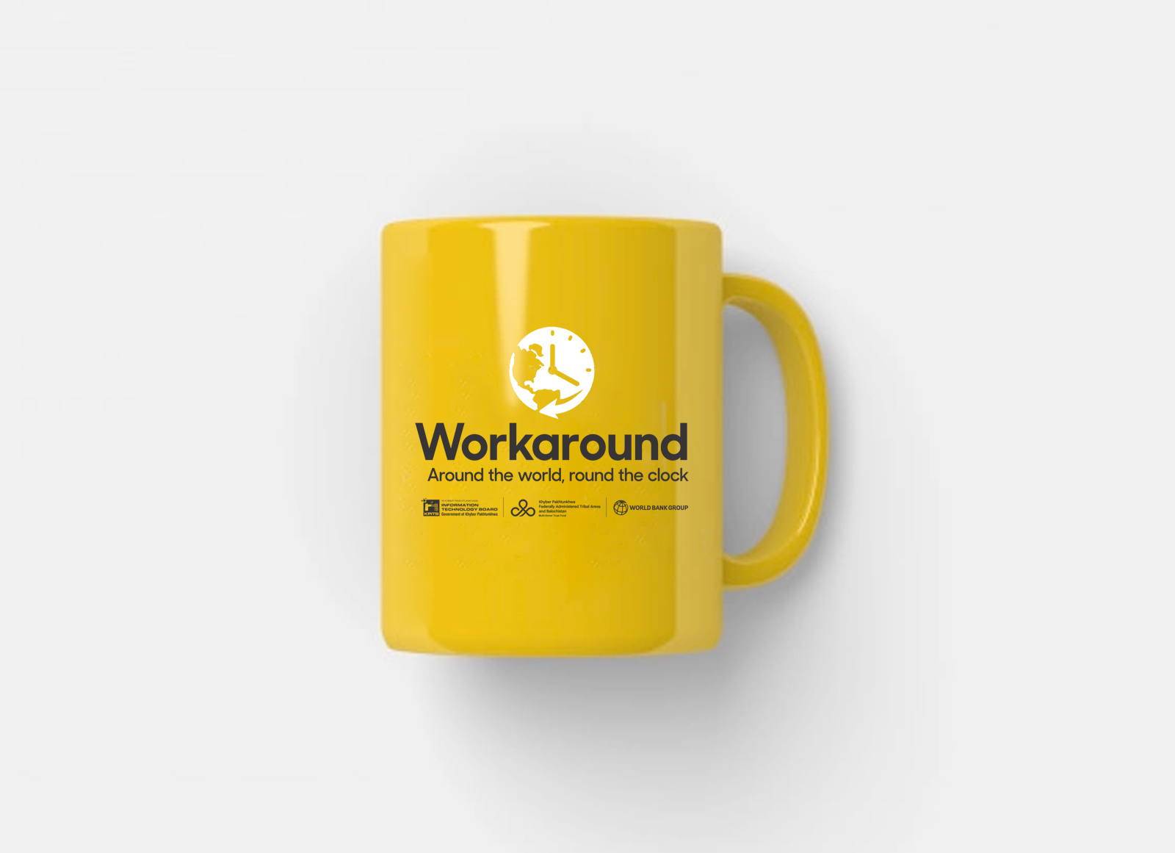
4 | Pen | 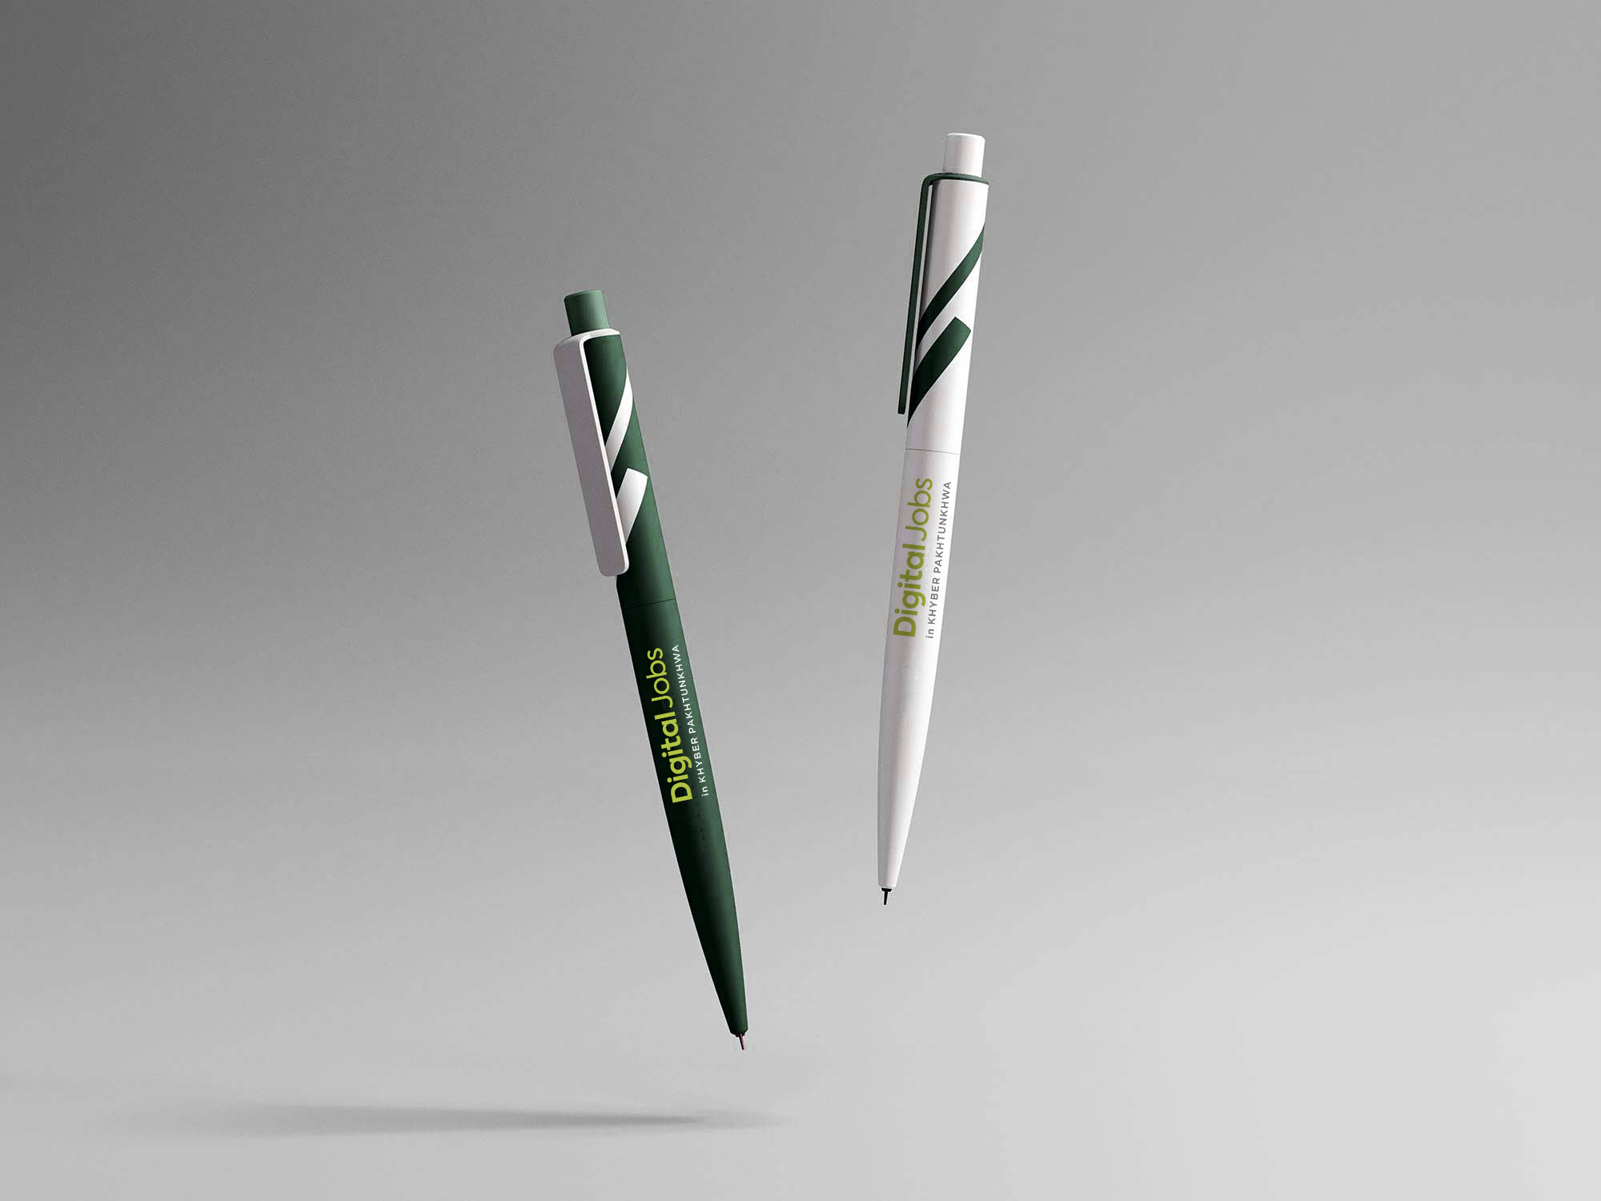
5 | Tissue Box | 
6 | File covers (Legal) | 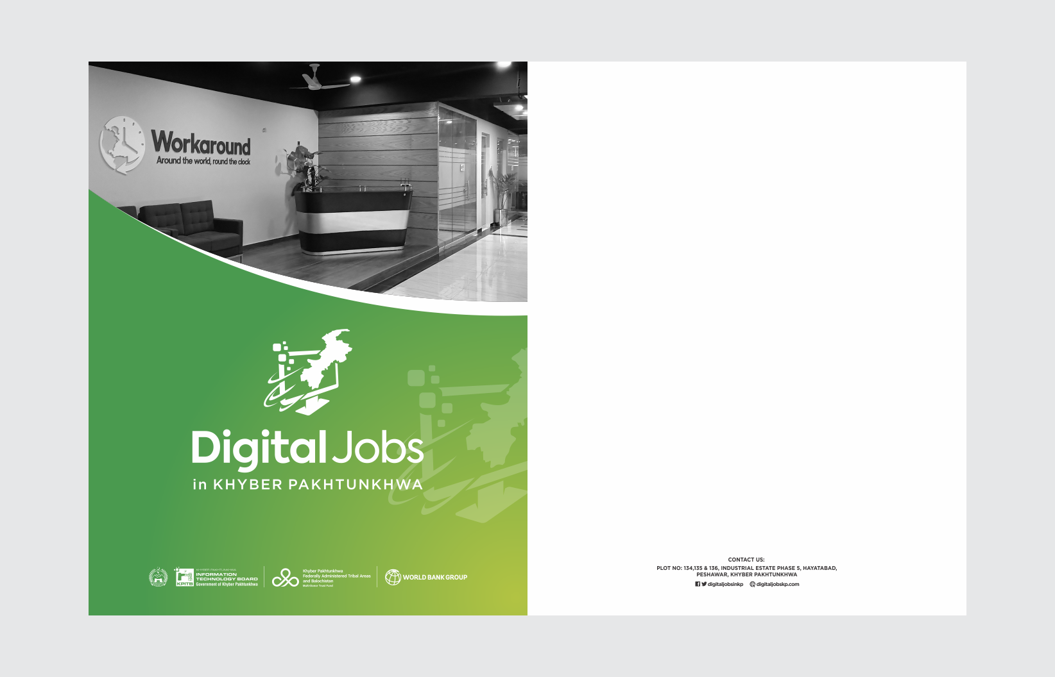
7 | Shields (9 x 4.5 inches) | 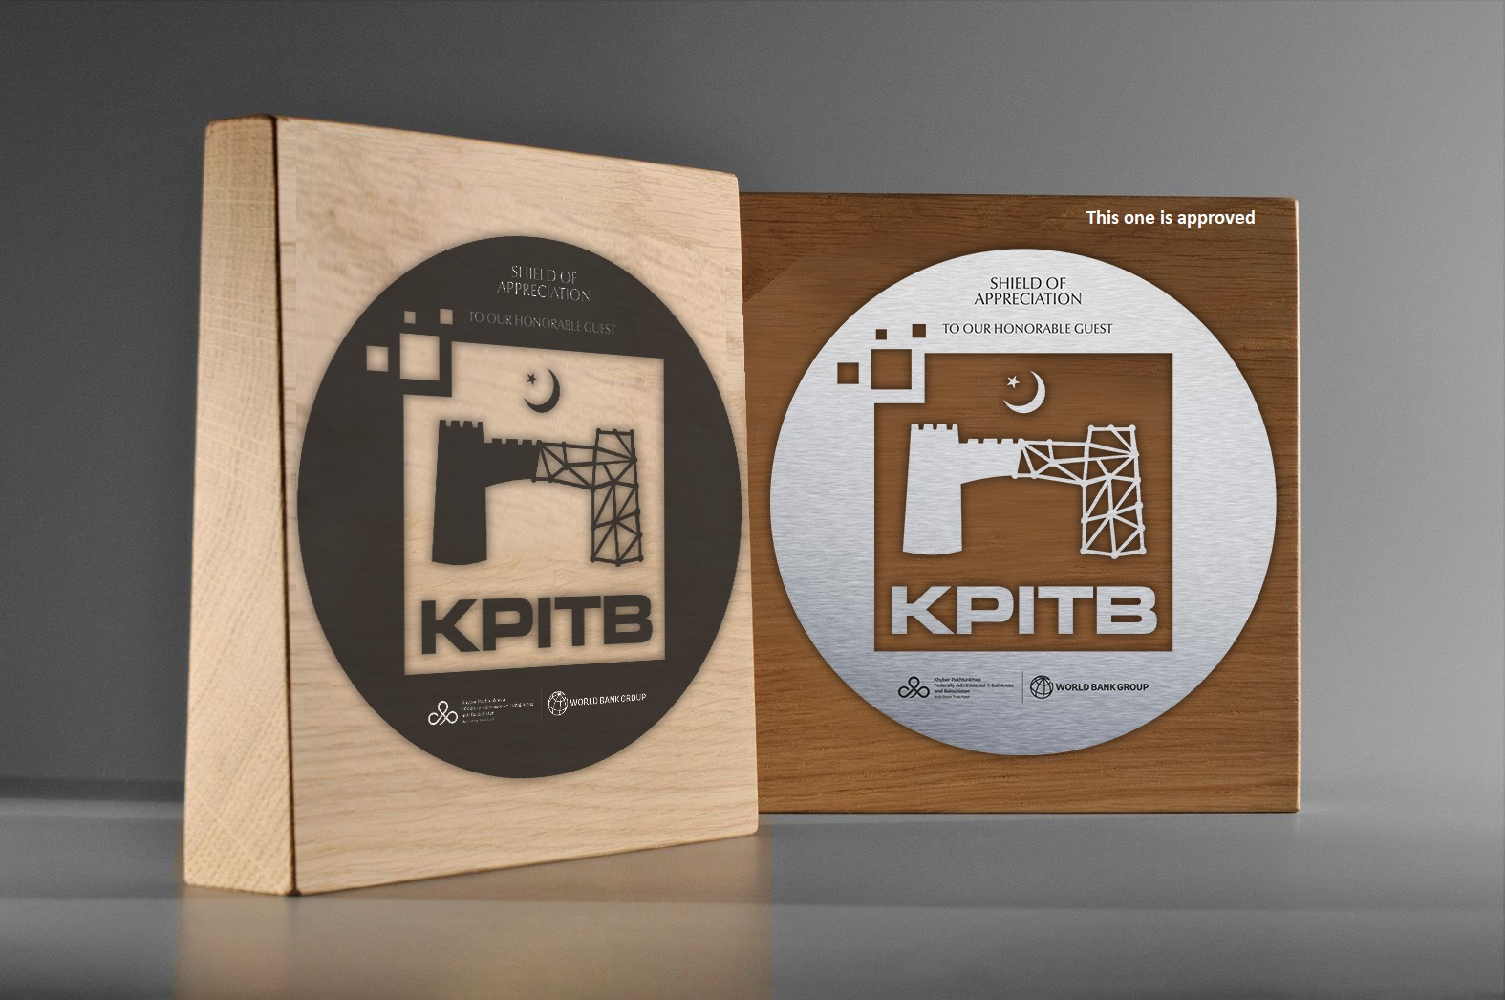
8 | Visiting Card | 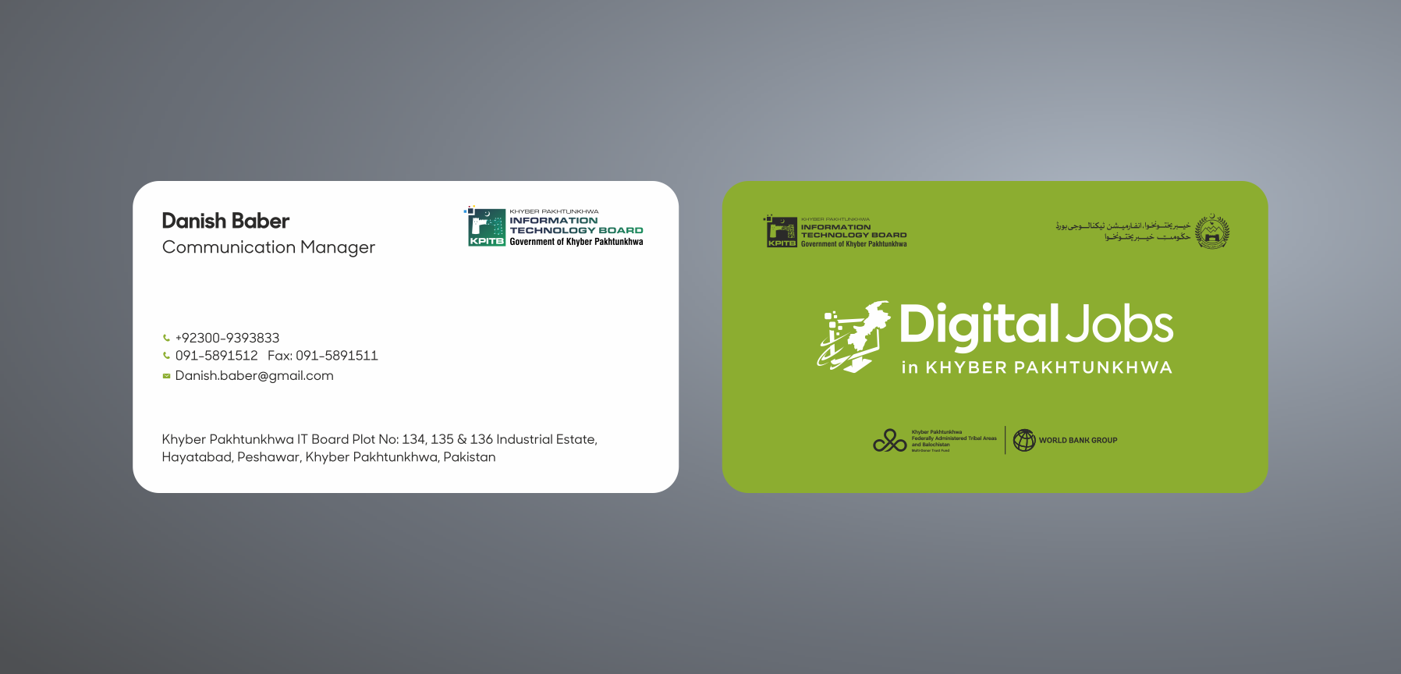
9 | Employee IDs | 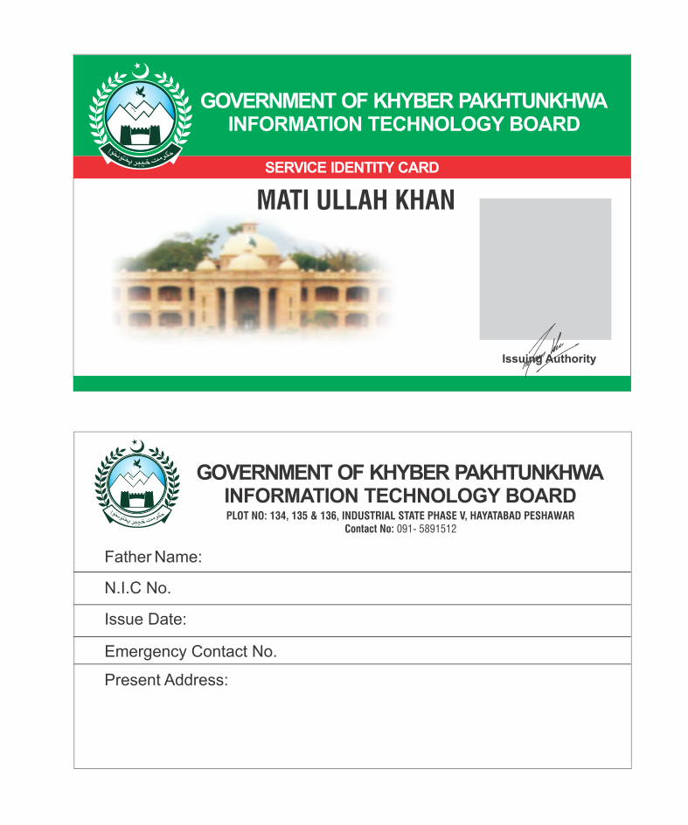
10 | Brochure (4 Colour) | 